Belgium Import Data: A Brief Account
Introduction
Belgium is a nation which lies in the middle of Western Europe. Its capital is Brussels. It has one of the most accessible and trade-oriented economies in the world. Belgium has a GDP of $600 billion. Global commerce is very important to the country’s local marketplaces, enterprises, and industries. It relies heavily on imports. According to Import Globals’ Europe Trade Data, Belgium is a main entrance to European trade since it is located along the North Sea. It has a well-developed transportation infrastructure and therefore serves as a logistics hub.
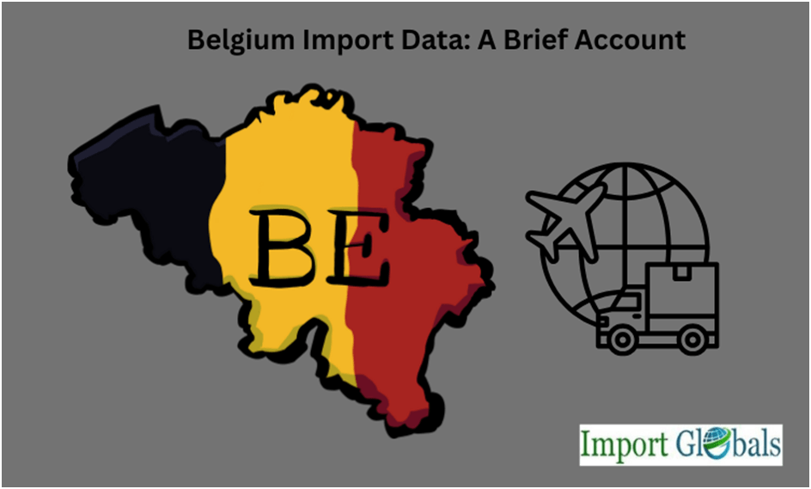
Belgium’s industrial sector, energy needs, and consumer demand need imports trade. The country’s economy is tightly connected to global supply chains. The European Union (EU) ensures a steady flow of goods and commodities sourced from many importer countries.
Belgium’s Global Import Performance
Belgium is one of the top importers in the world. It has a robust industrial base. It is a crucial transit point for trade across European region. Imports comprise a large part of its GDP since goods are often imported into Belgium. Further, those goods are exported to other parts of Europe. The country imports a lot of machinery, food, chemicals, mineral fuels, and stones.
Antwerp is one of the major ports in Europe. It is very important for Belgium’s trade and business. It acts as a crucial gateway for manufactured products, energy resources, and raw materials. These imported commodities are then mobilised in Belgium and its neighboring countries.
Important Imports for Belgium
Belgium’s import ecosystem is heavily influenced by the demands of consumers and businesses in the home market itself. Mineral fuels, notably crude oil, petroleum products, and natural gas, are some of the most important things that the country imports since it relies on imported energy.
Belgium’s strong life sciences and healthcare industries get a lot of help from imports of chemicals and medications. Belgium Export Data shows that vehicles, machinery, and electrical equipment are essential imports that help Belgium keep its technical and industrial sectors going.
Belgium also imports precious stones, mainly diamonds, because Antwerp is a significant worldwide diamond market hub. A lot of the things that are brought into the country are food, drink, and agricultural goods to meet domestic demand.
The Most Important Import Partners in Belgium
Belgium has strong ties to both European and non-European markets, which makes its import network quite diverse. Germany and the Netherlands are Belgium’s largest suppliers in the EU since they are nearby and have strong commercial links. France and Luxembourg are also key business partners.
Import Globals’ research on European custom data shows that Russia, China, and the United States are key suppliers of goods that come into the EU. The US sends chemicals, machinery, and energy items, while China sends electronics, consumer goods, and manufacturing equipment. Russia has always been a source of energy, but recent developments in the world’s politics have changed the way commerce works.
Belgium can keep its import system stable and well-balanced with this wide range of partners, which can adapt to changes in the globe.
Antwerp Port and its role in Belgium’s Economy
The Port of Antwerp is one of the busiest ports in Europe. It is considered an important part of Belgium’s economy. It makes it easier to import millions of tons of products, such as chemicals, machinery, consumer goods, natural gas, and crude oil, every year. Antwerp is crucial as it has advanced logistics, storage, and distribution systems.
Belgium customs data demonstrates that the country is involved in the trading of diamonds and other valuable jewels across the world. It obtains diamonds that are both raw and polished from places including South Africa, the United Arab Emirates, and India. This lends Belgium’s imports a unique touch.
The Future of Belgium’s Economy and Trade Balance
Belgium is a big re-export hub, therefore it gets a lot of imports. In some industries, it can even get more imports than it sends out. Even if this means trade deficits in some years, the overall economic impact is still favorable. Imports help local businesses and create jobs through the logistics and distribution networks.
In the future, Belgium’s imports are likely to alter because of things like the energy transition, the need for more diverse supply chains, and the rise of digital technology throughout the world. In the future, we will import goods differently since we will need more high-tech and eco-friendly stuff. But if we keep moving toward renewable energy sources, we might not need to import fossil fuels as much in the future.
Belgium’s Role in the EU’s Import System
Belgium Import Data shows that it is an important part of the EU’s import ecosystem because of its strategic position. People buy stuff in Belgium, and a lot of goods come into the EU there and then go to other countries. It’s easier to do business with other EU members and find partners in other nations if you are a member of the EU.
Belgium’s import system is good for its own economy and makes the EU market more competitive. It is much more vital to European trade since it is a logistics and distribution center that makes sure goods reach nearby nations rapidly.
Issues with Belgium’s trade in imports
Belgium has a lot of difficulties keeping track of its imports. The country has to acquire energy from other nations, which implies that changes in international prices and events that can’t be predicted harm it. Supply chain difficulties, as those created by the COVID-19 epidemic or political upheaval, highlight how risky it is to depend too heavily on outside sources.
In a nutshell
Belgium’s imports illustrate how open and connected its economy is to the rest of the globe. Belgium’s businesses stay open and satisfy the demands of its own people by trading a lot with other countries. Energy, chemicals, vehicles, diamonds, and other items are some of the most important commodities that come into the country. The Netherlands, Germany, the US, China, and France are still its main suppliers, which ensures it has a wide range of partners.
The Port of Antwerp makes it simpler for goods to move across the area, which strengthens Belgium’s position as an important European import hub. Belgium is in a good position to keep growing its imports in the years to come since it has strong infrastructure and is a member of the EU. This is despite problems like relying on energy and the unpredictability of international events. Import Globals is a leading data provider of Belgium import export trade data. Subscribe to Import Globals to find out more about global import and export between countries!
FAQs
Q1.What products does Belgium import the most?
Belgium’s biggest imports include mineral fuels, chemicals, equipment, automobiles, diamonds, and food.
Q2. Who are the main countries that Belgium imports from?
Belgium gets most of its goods from the Netherlands, Germany, France, the United States, and China.
Q3: What makes the Port of Antwerp vital for Belgium’s imports?
It is one of the main shipping terminals in Europe, moving crude oil, chemicals, equipment, and diamonds, and sending commodities all across the EU.
Q4. What problems does Belgium have with imports?
Belgium has problems, including relying on energy, prices changing all the time throughout the world, and problems with its supply chain.
Q5. Where can you find specific information about Belgium import data?
For additional information on current statistics, go to www.importglobals.com or send an email to info@importglobals.com.

